**SIMULINK MODEL OF ANTI-LOCK BRAKING SYSTEM WITH ROAD FRICTION COEFFICIENT ESTIMATION**



Prepared for



The Society of Automotive Engineers

Collegiate Club Number - SAEICCBIS022  
National Institute of Technology Karnataka

Prepared by

Kurma Eshwar Sai Srinivas – 181ME141 (Project Mentor)

Patrike Vedika Rajkumar – 191ME256

Diksha Negi – 191ME129

May 15, 2021

ABSTRACT

<Write in Less than 150 Words>

Table of Contents

SECTION – I INTRODUCTION 2

Timeline 2

Tools and Technologies 3

Brief Introduction 3

Literature Review 3

SECTION – II CONCEPT DEVELOPMENT AND EVALUATION 4

Introduction 4

Methodology 4

Results and Discussion 4

Conclusion 4

Future Scope 5

References: 5

# SECTION – I INTRODUCTION

## Timeline

|  |  |  |
| --- | --- | --- |
| Month | Week | Task Accomplished |
| Dec-20 | One | Introductory Meet – Project Start |
| Dec-20 | Two | Completed MATLAB Fundamentals Course from MathWorks |
| Dec-20 | Three | Learnt Simulink from SAE KEP |
| Jan-21 | Three | Started Learning Basic Vehicle Dynamics – (Brake Bias) |
| Feb-21 | One | Learnt Load Transfer Calculations for a Half Car Model – (NPTEL) |
| Feb-21 | Four | Project Review – 01 |
| Mar-21 | Two | Literature Review for ABS Simulink Model |
| Apr-21 | Four | Started Making Simulink Model of Braking System (Open Loop) |
| May-21 | One | Added PID Controller to the Open Loop Model and Tuned |
| May-21 | Two | Added Drag and Downforce to the Simulink Model |
| May-21 | Two | Project Review – 02 (Final Review) |
| May-21 | Three | Documentation and Submission of Final Report |

## Tools and Technologies

|  |  |  |
| --- | --- | --- |
| S. No | Tool / Technologies used | Remark |
| 1 | MATLAB  Modules Used: Simulink, Control Engineering Toolbox | Coding and Optimization |
| 2 | Microsoft Excel | Plotting graphs |

## Brief Introduction

An Anti-Lock Braking System is an active safety feature in aircrafts and land vehicles used to prevent wheel lock up and skidding during braking. This allows the driver to maintain more control over the vehicle. It can decrease the breaking distance on dry and regular roads. ABS requires improvement in the areas of stability, steerability and stopping distance.

In this thesis, a model of the quarter vehicle is developed and used to study the braking performance of a straight-line braking test vehicle on flat dry asphalt road in MATLAB-Simulink software environment. The vehicle model includes the aerodynamic model and a model of antilock braking system. As this is a simulation model, there is no chance of using a real-time sensor for getting the wheel speed and vehicle speed. We have used newton’s kinematic equations to get the values of the same. We have avoided the hydraulic modulator and we are directly adjusting the brake torque from the feedback loop.

## Literature Review

Sharkawy has studied the changes in coefficient of friction at various road conditions. We have extracted friction formula from this literature and have plotted the same at various velocities. He has also tuned the ABS with Genetic algorithm and fuzzy. However, we have made an attempt to tune the ABS PID model with Genetic algorithm.

Bhivate has made the Simulink model of Antilock brake system without the aerodynamic compenents. He has used state space equations of motion to model the Simulink model. In this project we did the Simulink model with direct calculation and the results were reasonable matching. Direct calculation is a much simpler method.

Rangelov has modelled antilock braking system for a quarter car model on a flat as well as uneven road. He has made the ABS based on various methodologies like slip control, acceleration control, tire moment control braking. He has also included suspension model to the quarter car vehicle.

Harifi made primary controller design has been improved using integral switching surface to reduce chattering effects. He also he compared the performance of the designed controller with three of the prevalent papers results to determine the performance of sliding mode control integrated with integral switching surface.

# SECTION – II CONCEPT DEVELOPMENT AND EVALUATION

Introduction

The ABS consists of wheel speed sensor, hydraulic modulator and an Electronic Control Unit (ECU). It has a feedback system which finds out the error between the actual and desired slip ratio and adjusts the Brake Pressure accordingly to get the optimum slip ratio and maximum traction. They System Shuts down if the vehicle speed is under the pre-set threshold.

Before getting into more details, it is important to understand the motivation and need to prevent wheel skidding. wheel locking is when the tyre stops rotating under braking and slides along the top of the surface. It is bad firstly because it is less efficient (coefficient of kinetic friction is lower than coefficient of static friction) (explained in fig under Subsystem of Simulink) and so will take longer to slow you down but more importantly also because it can wear a flat spot on the tyre if it locks for a long time. Flat spotted tyres tend to lock more easily in the future at the point of the flat spot and also cause vibrations which can damage the car.

During breaking, you are using brake pad friction on the wheels to slow you down. When you break hard, sometimes, the brake pads stop the wheel from spinning. in other words, when the brake pads are so tightly pressed against the drum/disc, the wheel locks up. Now although the wheel is not moving, because of your momentum, you will still keep moving forward for a short distance, this is skidding, where the tyres/tires don’t roll over the tarmac but are dragged. You have very little control over the vehicle when this happens.

Front wheels locks:

Loss of steerability due to absence of lateral friction. If the front wheels get locked, the driver loses the steering control. This can be detected more readily by an experienced driver and the driver can regain control by releasing the brakes.

Rear wheels locks:

Rear wheels lockup is more critical as directional stability is lost and there are chances that the car spins out. In this scenario the vehicle over responds to the steering and the rear part of the vehicle rotates about its axis if any lateral perturbation is applied to the vehicle.

Balance Bar

The function of a balance bar is to allow the adjustment of brake line pressure distribution between two master cylinders. The torque on one side of the bar must balance the torque on the other side. Balancing bars take the force from one side and give it to the other.

Brake bias/Brake balance

Brake balance, also called brake bias, front to rear, is critical to the stability of a racing car during the braking and during turn-in phase; too much rear brakes will tend to cause the car to spin; too much front and car will not turn in. Brake biasing is only seen in racing cars.

Brake biasing is the condition where we give different brake forces to rear and front wheels. Generally, we give more braking force to the front than to the rear as the centre of gravity tends to move forward when we apply brakes. For the stability of the vehicle both the wheels should skid at the same time.

## Methodology

Assuming that the mass is equally distributed on all the four wheels of the vehicle. We consider the mass of a quarter car model at 0.25*m. The Kinematic equations of motion of the quarter car model are as follows:

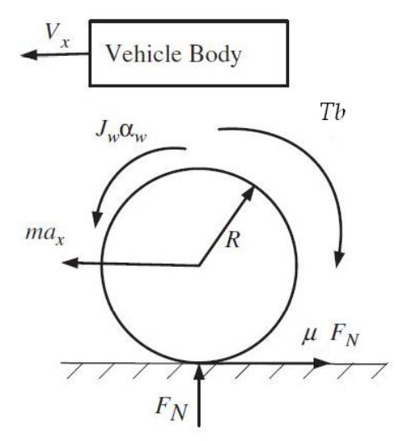Equation for braking force balance in longitudinal direction (vehicle)

Figure Quarter Car Vehicle Model

The Down Force on the vehicle is

The Normal Force of the Vehicle

The Drag Force of the Vehicle

For a Quarter Car Model:

The Equation of Motion from Newton’s Second Law

Balancing the Torque at the Wheel Centre

(Assuming the Downforce and Drag forces are passing through the wheel centre, we have not included them in the torque equations)

Now, Wheel Slip Ratio can be defined as

In Case of pure rolling, we have , and the value of . On Contrast, in case of skidding we have which make the value of .

In this paper, the tire friction model introduced by Burckhardt (1993) and adopted in Harifi et al. (2008) has been used. It provides the tire-road coefficient of friction as a function of the wheel slip and the vehicle velocity Vx. Researches show that the road coefficient of adhesion is a nonlinear function of wheel slip () and the vehicle velocity (Vx) in a specified road condition. The road friction coefficient function is as follows:

Where,

c1 is the maximum value of friction curve

c2 is the friction curve shapes/slope

c3 is the friction curve difference between the maximum value and the value at = 1

c4 is the wetness characteristic value, which varies from 0.02-0.04 s/m

Figure Road friction coefficient v/s Wheel Slip ratio at vehicle speed 30 m/s

From the above graph it is observed that the maximum slip is attained at a slip ratio of 0.2. However, in case of Snowy and icy road there is no significant change in the road friction coefficient at different values of slip. The Plots Below are plots of different types of road at varying vehicle speeds.

|  |  |  |  |
| --- | --- | --- | --- |
| **Surface** | **C1** | **C2** | **C3** |
| Dry asphalt | 1.2801 | 23.99 | 0.52 |
| Wet asphalt | 0.857 | 33.822 | 0.347 |
| Dry Concrete | 1.1973 | 25.168 | 0.5373 |
| Snow | 0.1946 | 94.129 | 0.0646 |
| Ice | 0.05 | 306.39 | 0 |
| Current Study | 1.28 | 12 | 0.28 |

Table Road friction coefficient parameters set for different road surfaces.

The Value of c4 varies from 0.02 s/m to 0.04 s/m depending on the wetness of the road.

Figure Road friction coefficient of road of current study at different velocities

Figure Road friction coefficient of Snowy road at different velocities

Figure Road friction coefficient of Wet Asphalt road at different velocities

Figure Road friction coefficient of Dry Concrete road at different velocities

Figure Road friction coefficient of Dry Asphalt road at different velocities

Figure Road friction coefficient of Icy road at different velocities

There is no significant change in the wheel slip point at which friction attains its peak value for almost all kinds of roads. So, slip ratio of 0.2 can be made as a universal optimum slip value.

A feedback control system is a closed loop control system in which a sensor monitors the output (slip ratio) and feeds data to the controller which adjusts the control (brake Torque) as necessary to maintain the desired system output (match the wheel slip ratio to the reference value of slip ratio). The PID Controller flow diagram is as shown below.

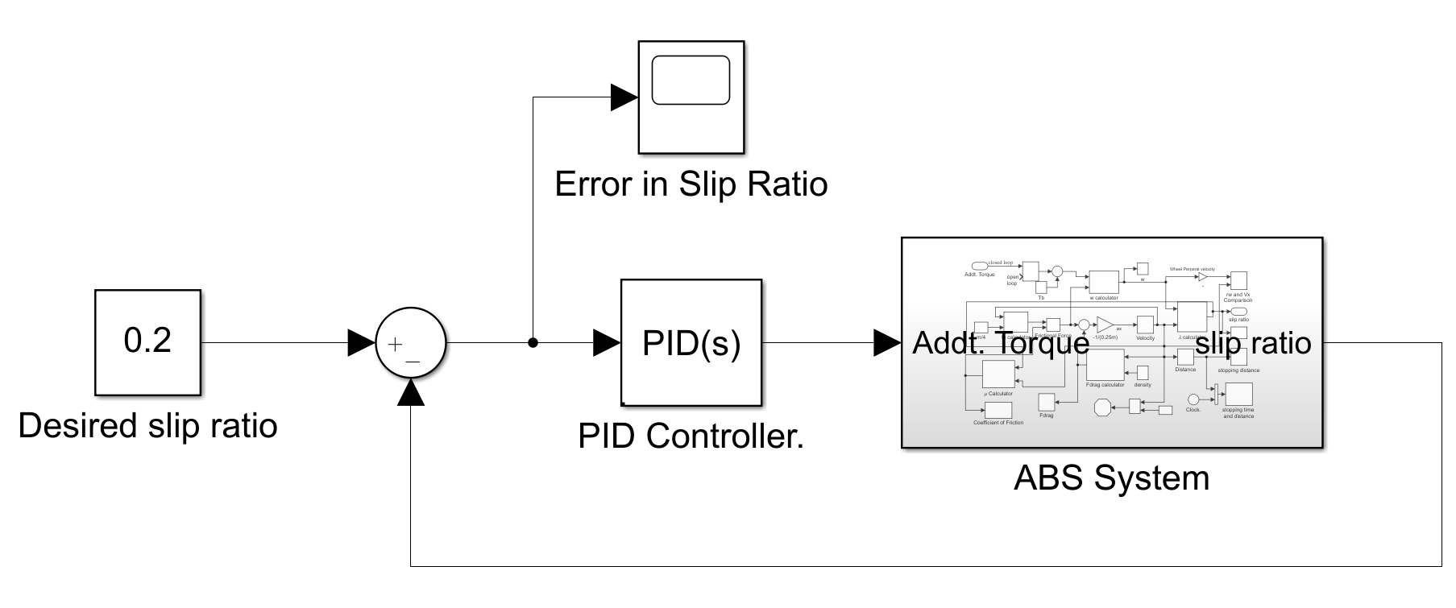

Figure The ABS Control System

The PID Tuner take the Error in slip ratio and accordingly sends the additional torques (either positive or negative) and gets the value of slip ratio again. This process continuous till the Vehicle velocity is less than the threshold i.e., it is 0.5 m/s in our project. In our project we have tuned the PID Controller manually and we have achieved fastest response at Kp = 250000; Ki =100000; Kd =100.

The Flow Diagram the Complete Vehicle Dynamics Block of the ABS Model is as follows:

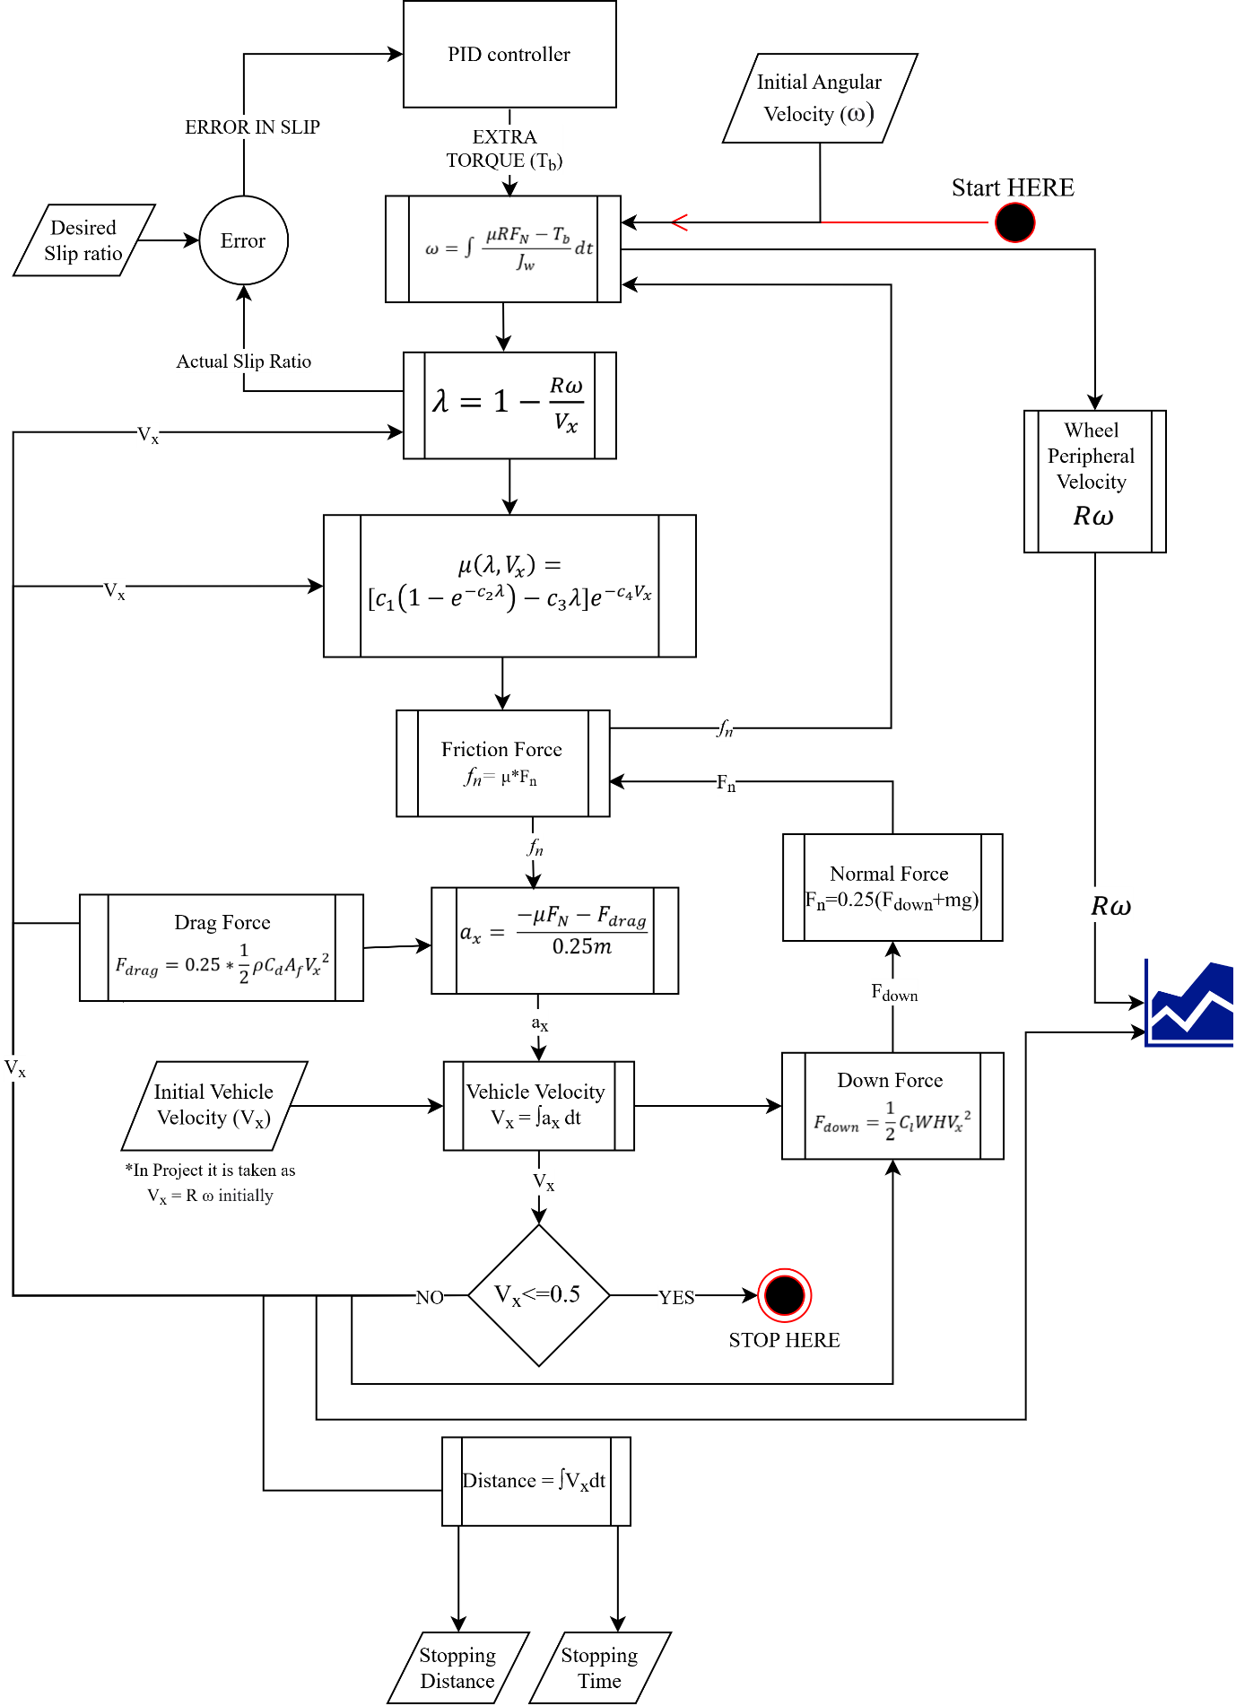

Figure Complete Flow Diagram of the Simulink Model

The Simulink model of the above Figure is as shown below. To avoid confusion various subsystems have been made.

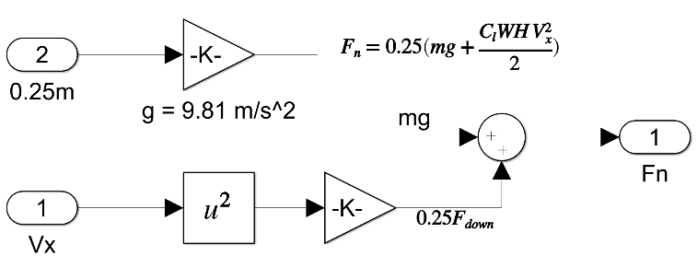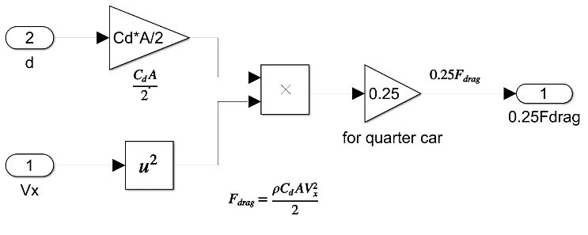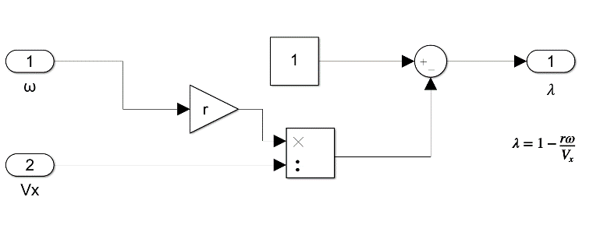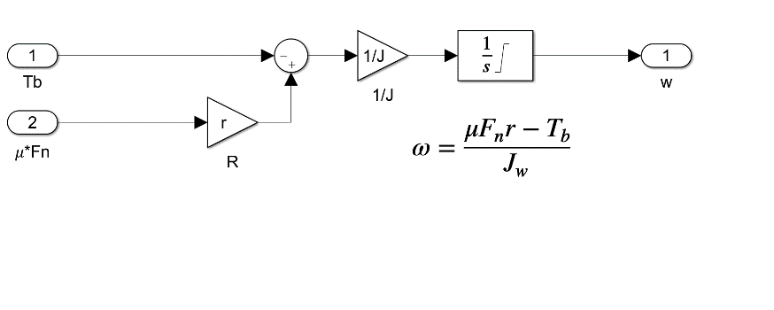 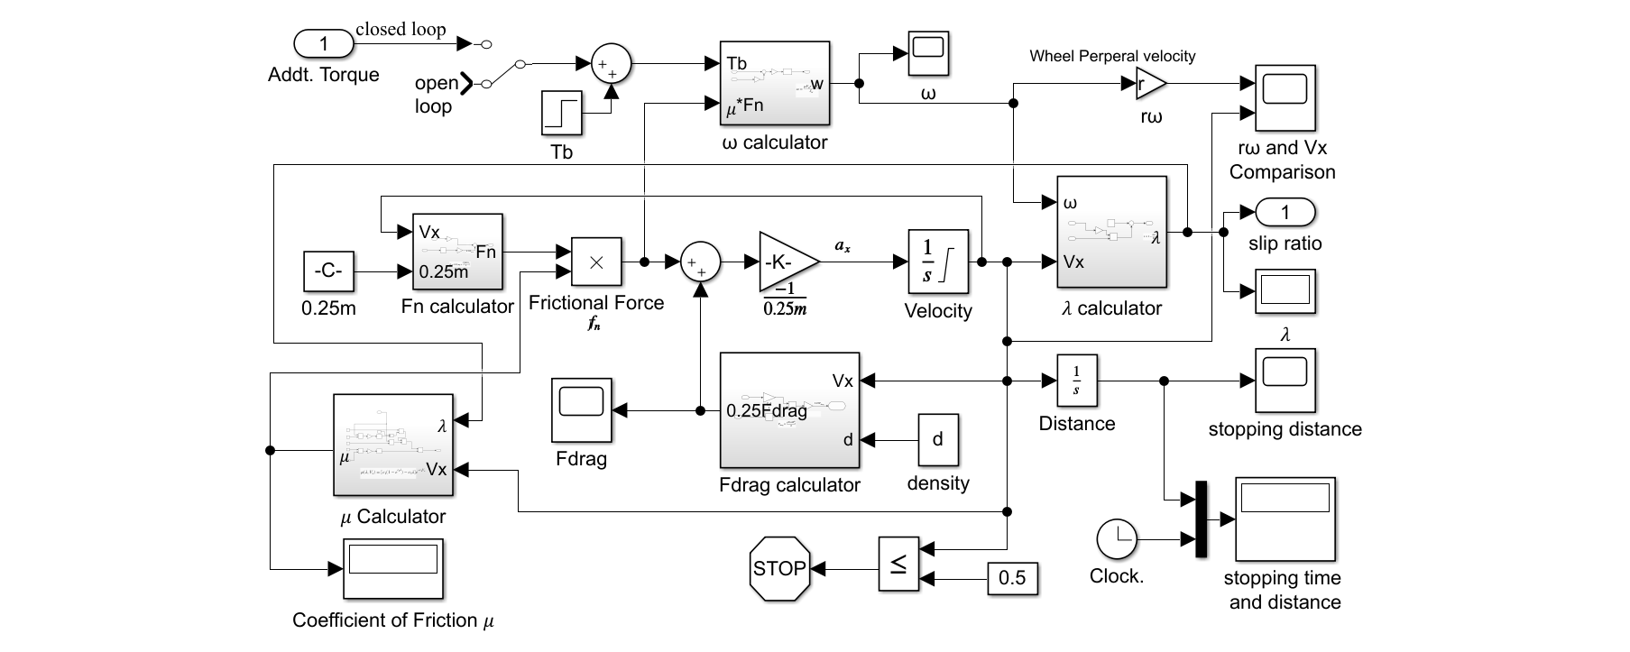

Figure Frag Force Calculator

Figure Normal Force Calculator (Downforce Included)

Figure ω calculator Sub-System

Figure 𝜆 Calculator Sub-System

Figure Simulink Model of ABS Sub-System

The Flow diagram is self-explanatory.

## Results and Discussion

<START HERE>

## Conclusion

<START HERE>

## Future Scope

<START HERE>

References:

* -
* -